COMPUTER ARCHITECTURE ASSIGNMENT 3

Name: Chinthakommadinne Vinay Kumar

RollNo.: B210554CS

LIP_2 implementation :  
  
In the LRU policy, each incoming entry is inserted at the most recent position in the LRU recency stack by assigning it the lastTouchTick value of the current simulation tick. This ensures that the newest entry has the highest recency in the stack. However, to meet the requirements of the LIP_2 insertion policy—where the incoming entry is placed in the second-most recent position—the lastTouchTick value must be set such that the entry appears as the second-most recently accessed.

In the extended class implementing this behavior, the lastTouchTick values are managed using a min-heap structure. This approach efficiently tracks the smallest and second-smallest values, as the heap automatically maintains ordering. When a reset occurs, the lastTouchTick of the new entry is assigned a value just slightly higher than the smallest lastTouchTick but lower than the most recent one, allowing the new entry to be placed correctly within the recency stack.

By leveraging the min-heap structure, the smallest and second smallest lastTouchTick values are readily accessible, simplifying the updates required as new entries are added or existing ones are replaced. This setup ensures that the lastTouchTick values are efficiently maintained and that the insertion policy aligns with the requirements of LIP_2.

My bench marks are   
  
hmmer  
milc  
specrand  
  
the plots obtained are as follows  
  
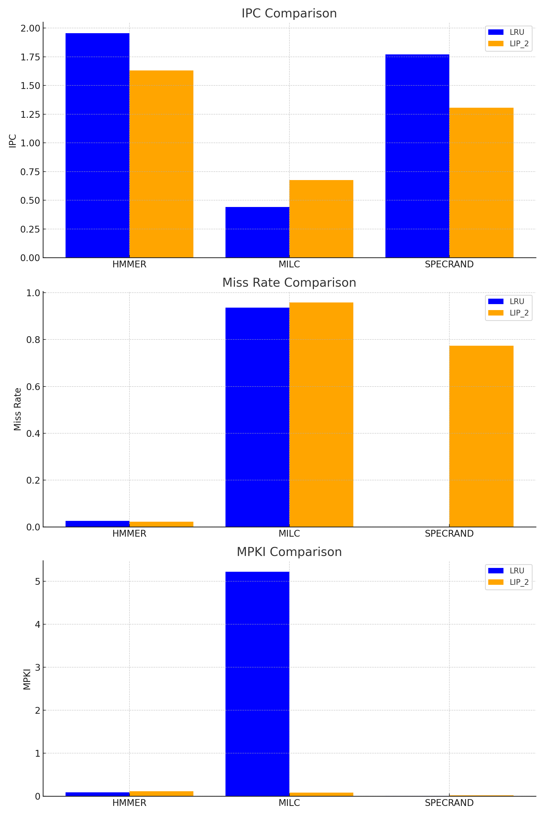

## MPKI Calculation Details

MPKI (Misses Per Kilo Instructions) is calculated using the formula:

MPKI = (Number of Misses / Total Instructions Simulated) × 1000

HMMER:  
 - LRU: MPKI = (13732 / 150000007) × 1000 ≈ 0.0915  
 - LIP_2: MPKI = (12397 / 110000002) × 1000 ≈ 0.1127  
  
MILC:  
 - LRU: MPKI = (8354 / 1600002) × 1000 ≈ 5.2212  
 - LIP_2: MPKI = (9185 / 110000003) × 1000 ≈ 0.0835  
  
SPECRAND:  
 - LRU: MPKI = (461 / 55434251) × 1000 ≈ 0.0083  
 - LIP_2: MPKI = (1530 / 67724705) × 1000 ≈ 0.0226

LRU baseline dominates over lip_2 policy   
so LRU policy is better.